Below are the results for the ModelSim simulations:

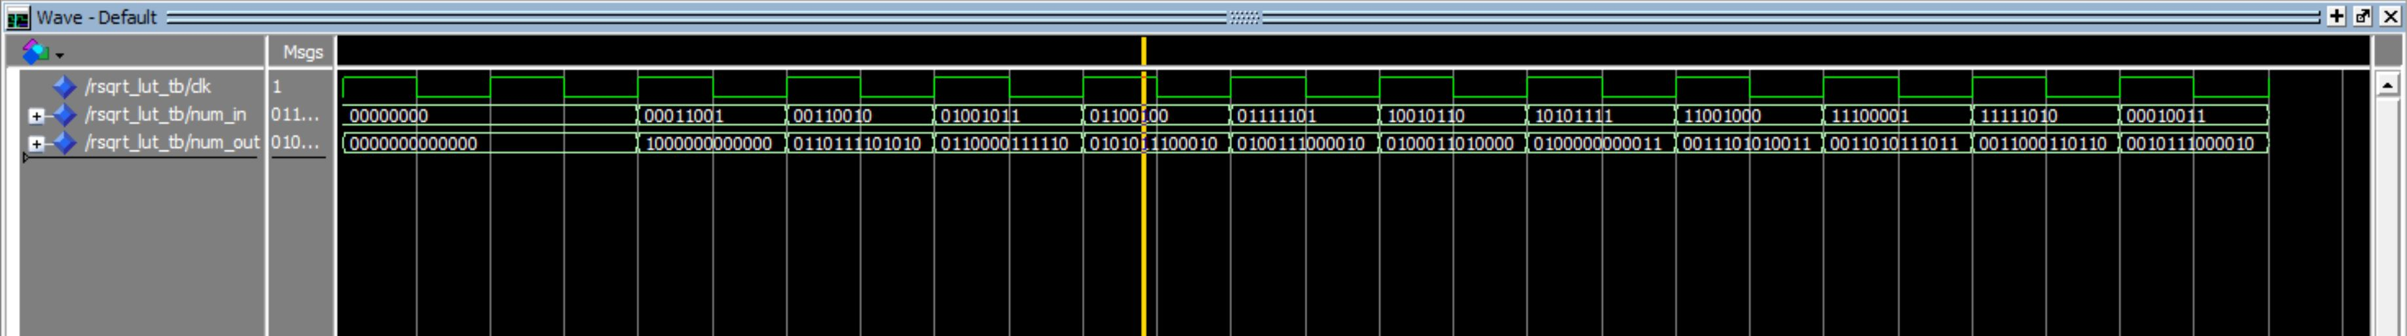

And the matching values confirmed on the MIF (note that it takes 1 clock cycle for the value to appear, e.g. the value for 00000000 appears under 00011001. This is expected and will be compensated for in our design) It can be compared to the above values to confirm accuracy.





















